
Task 11
Spark Streaming
Artificial Intelligence Infrastructure course

2026-06-16
AUTHOR: MICHAEL O’SHEA (2025244317)

Introduction
This assignment was designed to introduce Spark Core, learn about Spark SQL and Spark DataFrames, and understand Spark Streaming.

1.Steps Followed
The steps followed were:
- Downloaded the code for mod17-sparkStreaming from GitHub.
- Built the Docker image
docker build -t spark-custom .
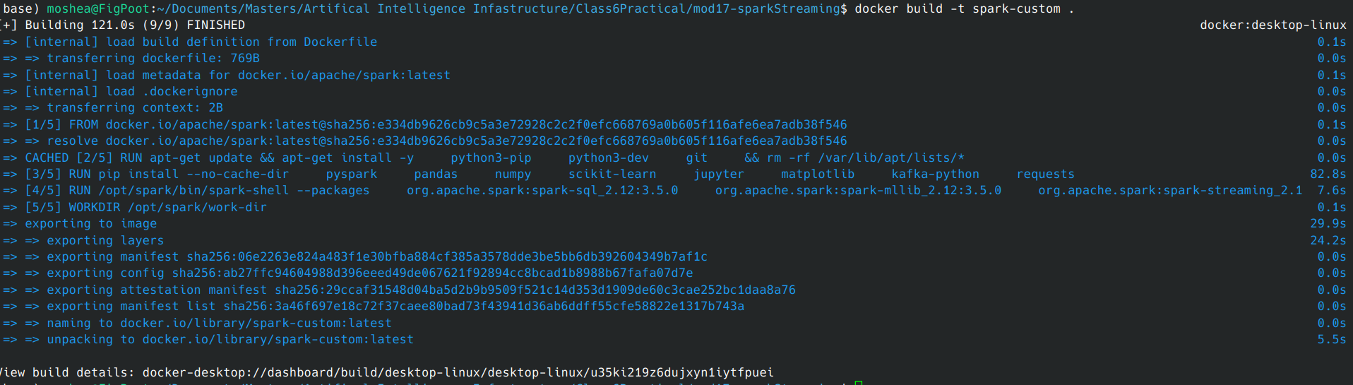
- Started the producer with:
  - docker exec -it spark-worker-1 bash
  - cd /opt/spark/mycodeStreaming/flights
  - python3 fileProducer2.py

- Started the consumer with:
  - docker exec -it spark-worker-1 bash
  - cd /opt/spark/mycodeStreaming/flights
  - python3 fileConsumer2.py

- Output from the consumer was :
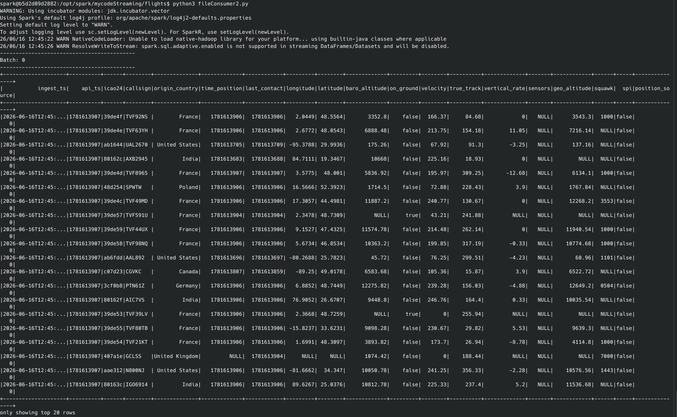
- I modified the code to create the following queries:
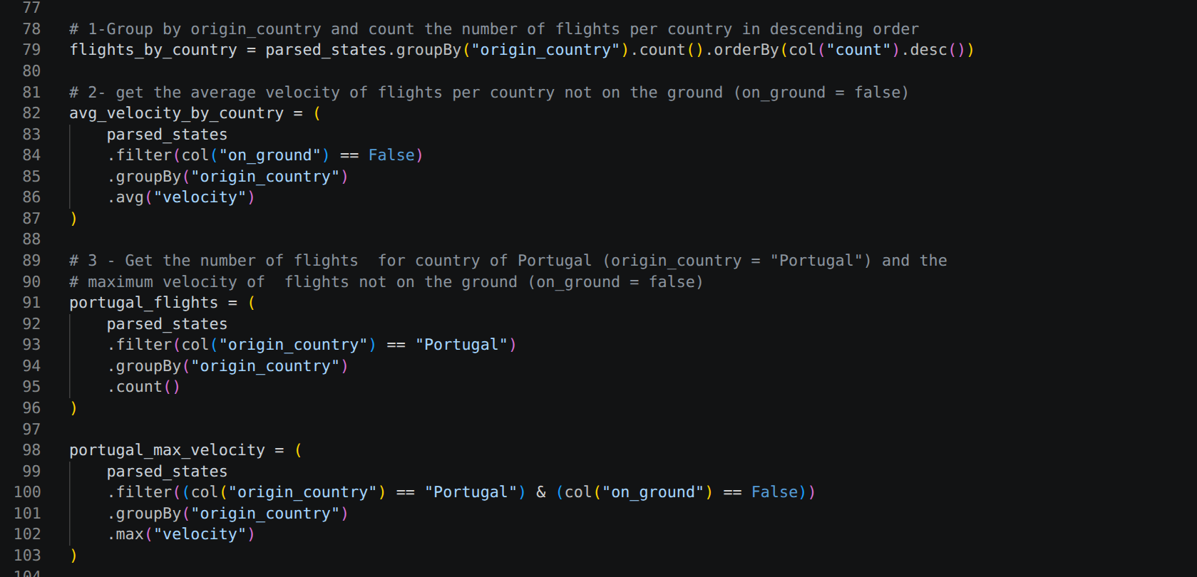
- I then modified the code to output the results of these queries to the console:
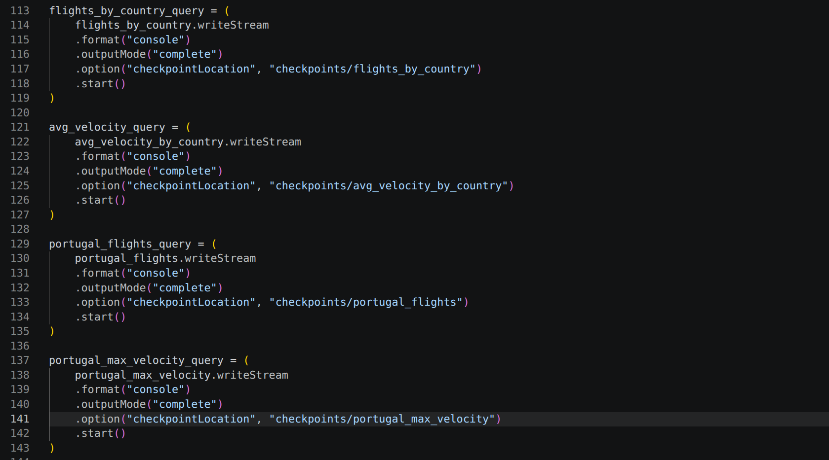
- Verified the output after running the producer and then the consumer:
Portugal Count Portugal max(velocity)
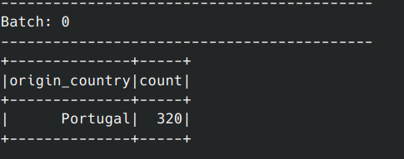
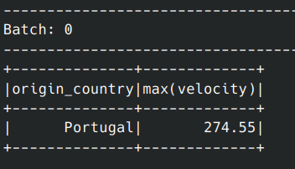

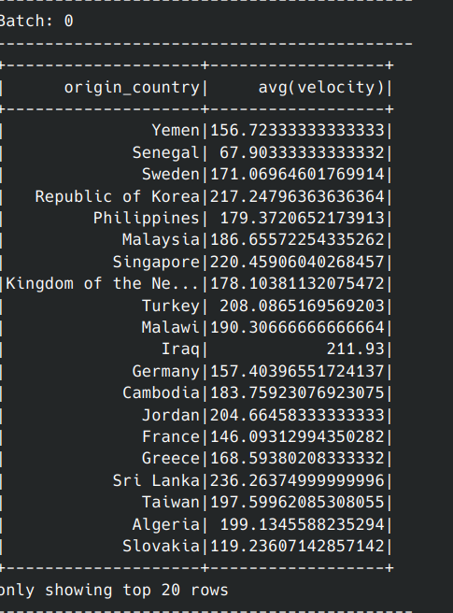
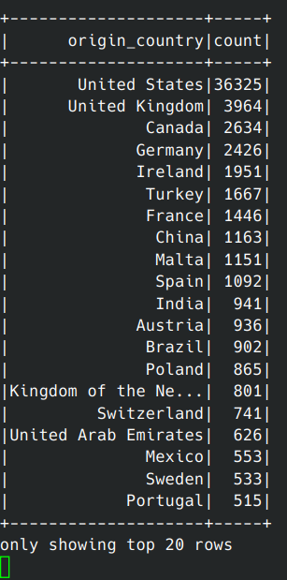
Origin Country count Origin Country avg(velocity)

2. Questions and Results Achieved

The following are the answers to all the questions posed in the Exercise and how they were found:

Q1. Explore the code of the fileConsumer2.py script. Explain in brief words what
is being done.
- Purpose: consume a JSON stream of OpenSky state vectors and turn each state array into a structured row.
- Schema: declares ingest_ts, api_ts, and states (an array of arrays).
- Parsing: explodes states into individual state rows and maps each array index to a named column from STATE_FIELDS (e.g., origin_country, velocity, on_ground).
- Finally: writes results to the console in append mode with a checkpoint at checkpoints/opensky_stream and calls awaitTermination().

Code Changes for Q2-Q4, building queries:


Executing Queries:


Q2. Provide evidence that you can retrieve the count per each country and

explain what you have modified in the code.

See the code changes above.

Q3. Provide evidence that you can retrieve the average of velocity per each

country and explain what you have modified in the code.

See the code changes above
Q4. Provide evidence that you can retrieve the maximum velocity for Portugal and explain what you have modified in the code?


See the code changes above

Q4.1. Provide evidence that you can retrieve the maximum velocity per each
country and explain what you have modified in the code?
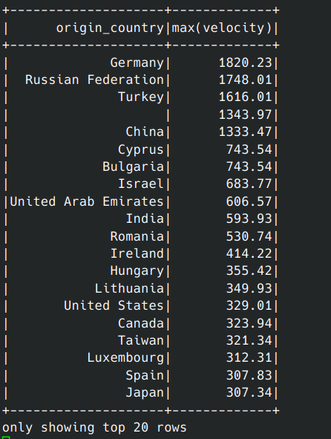

Code changes where:

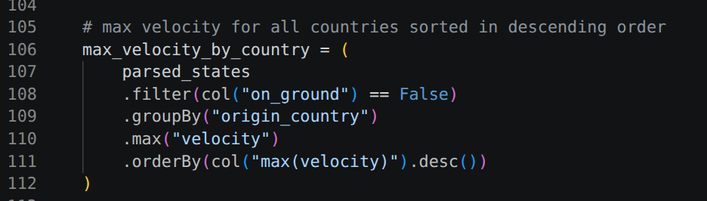
and

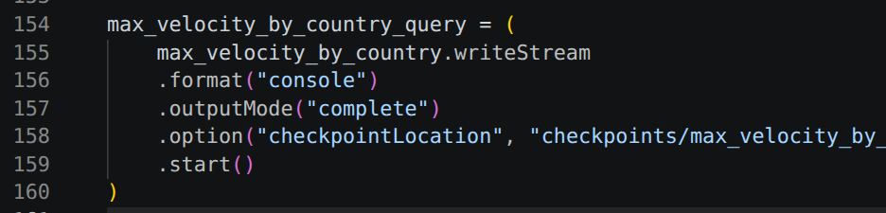

Results achieved:

- Built and deployed the Docker image via Docker compose.
- Used “docker exec” to run the producer and consumer.
- Verified that both worked correctly.
- Updated the consumer to output a number of different flight metrics.
- Verified that the consumer displayed these new metrics correctly.

3.Lessons Learned

A couple of important lessons were learned while completing this exercise:

- A master container from a previous Docker Compose session was still running and had to be removed before starting a new Docker Compose deployment. This occurred because I stopped the environment using Ctrl+C instead of docker compose down.
- Multiple queries issued at the same time may not return in the order they were sent in.
- The producer must start before the consumer; otherwise, the consumer fails.
